Exploratory Data Analysis of a Telecommunication
Marketing Campaign

Part 1

By: Vanshika Lakhani

Table of Contents
PROBLEM FORMULATION ............................................................................................................. 3
BUSINESS CONTEXT .................................................................................................................................. 3
RESEARCH PROBLEM ................................................................................................................................. 3
RESEARCH QUESTIONS .............................................................................................................................. 3
OBJECTIVE ............................................................................................................................................... 4 DATA PREPROCESSING ................................................................................................................ 4
EXPLORATORY DATA ANALYSIS (EDA)............................................................................................. 4
DESCRIPTIVE STATISTICS............................................................................................................................. 4
TARGET VARIABLE DISTRIBUTION .................................................................................................................. 5
UNIVARIATE ANALYSIS ................................................................................................................................ 5
BIVARIATE ANALYSIS .................................................................................................................................. 6
MULTIVARIATE RELATIONSHIPS ..................................................................................................................... 7
CORRELATION ANALYSIS............................................................................................................................. 8
CAMPAIGN CONTACTS AND SUBSCRIPTION RATE ............................................................................................. 9
CONCLUSION ............................................................................................................................ 10
REFERENCES ............................................................................................................................. 10

Problem Formulation

Business Context
The dataset originates from a telecommunication company that recently launched a marketing campaign to promote adoption of a new subscription plan. Marketing campaigns in this industry are costly and resource-intensive, and understanding which customers are most likely to subscribe is crucial for improving return on investment. The company’s primary objective is to identify customer segments that are more responsive to the campaign so that future marketing efforts can be targeted more efficiently. Recent research has also highlighted the success of hybrid ensemble models, achieving up to 95.6% accuracy in predicting customer responses to telemarketing campaigns(Saeed et al, 2022).

Research Problem
The central problem is to explore the dataset in order to:
- Gain insights into the demographic and behavioral characteristics of customers.
- Identify which variables most strongly influence whether a customer subscribes.
- Detect patterns and relationships that can guide the design of more effective campaigns.
The response variable of interest is subscribed (binary: 0 = no, 1 = yes). This indicates whether a client subscribed to the plan after the campaign contact. Previous studies show that call duration is one of the most influential predictors of subscription success (Peter et al., 2025; Moro et al., 2014).

Research Questions
The following guiding questions shaped the exploratory data analysis (EDA):
- Which demographic factors (e.g., age, marital status, education) are associated with higher subscription rates?
- How do financial variables (e.g., balance) relate to customer responsiveness?
- Does the method of contact (e.g., cellular vs. telephone) or timing (month) influence campaign success?
- Are previous campaign interactions (e.g., campaign frequency, prior outcome) predictive of subscription likelihood?
Based on these questions, the following hypotheses were proposed:
- H1: Customers with fewer financial obligations (e.g., no housing or personal loans) are more likely to subscribe.
- H2: Campaign success is more dependent on campaign-related factors (duration, timing, contact method) than demographic attributes.
- H3: Customers with positive previous campaign outcomes are significantly more likely to subscribe again.
- H4: Excessive contact attempts reduce the likelihood of subscription.
This framing established the analytical context, linking customer segmentation with campaign effectiveness.

Objective
The aim of this exploratory data analysis is therefore to provide a comprehensive understanding of customer behaviour in relation to the marketing campaign, highlight key drivers of subscription, and establish data-driven insights to support future marketing strategy.

Data Preprocessing
A rigorous data preprocessing stage was undertaken to ensure that the dataset was clean, consistent, and suitable for exploratory data analysis. The steps below describe the process in detail.
- Data Inspection and Cleaning: Initial inspection revealed no missing values in the dataset; however, certain variables contained “unknown” categories, which were treated as missing information. These were retained for analysis as they represented genuine uncertainty in customer records.
- Handling Irregularities: The variable pdays contained more than 39,000 values recorded as “999,” indicating customers who had not been previously contacted. Instead of dropping this variable, it was retained as an important feature but interpreted cautiously, since “999” reflected lack of prior contact rather than a numeric value.
- Variable Transformation: Categorical variables such as job, marital, education, housing, loan, contact, month, and poutcome were kept in their categorical form for univariate and bivariate analysis. Numeric variables (age, duration, campaign, previous, pdays) were retained as continuous values for descriptive and correlation analysis.
- Error Checking: Duplicate records and outliers were checked. Outliers in variables such as campaign and duration were retained, as they represented extreme but realistic cases of repeated contacts and long calls that could influence outcomes.
Through these pre-processing steps, the dataset was confirmed to be free of technical errors and ready for exploratory analysis.

Exploratory Data Analysis (EDA)
The exploratory data analysis was conducted to understand customer demographics, campaign performance, and their relationship to subscription outcomes. The analysis followed a structured approach, beginning with descriptive statistics, followed by univariate and bivariate analyses, correlation tests, multivariate relationships, and campaign-specific insights.

Descriptive Statistics
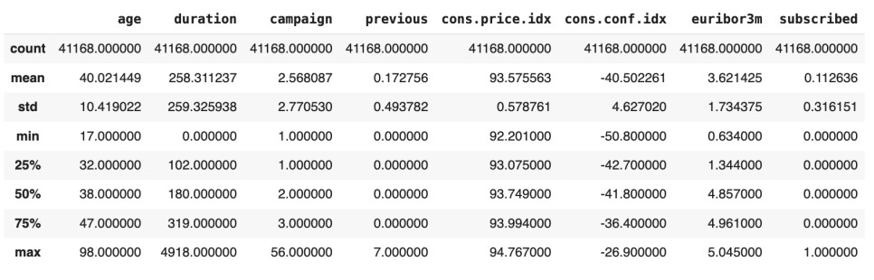

Figure 1: Descriptive statistics of numeric variables
To provide an initial overview, descriptive statistics were generated for the dataset of 41,168 records.
Age ranged from 17 to 98 years (mean = 40), reflecting a predominantly working-age population. Duration of calls varied widely, with a median of 180 seconds and several extreme outliers. Campaign contacts were highly skewed, with most customers contacted only 1–3 times, while previous contacts were minimal (median = 0). Economic indicators captured the macroeconomic context, and the target variable showed that only 11.3% subscribed, confirming strong class imbalance.

Target Variable Distribution
The response variable in this dataset is subscribed, which indicates whether a client accepted the new subscription plan (1 = Yes) or did not (0 = No). Figure 1 below shows the distribution of this target variable.
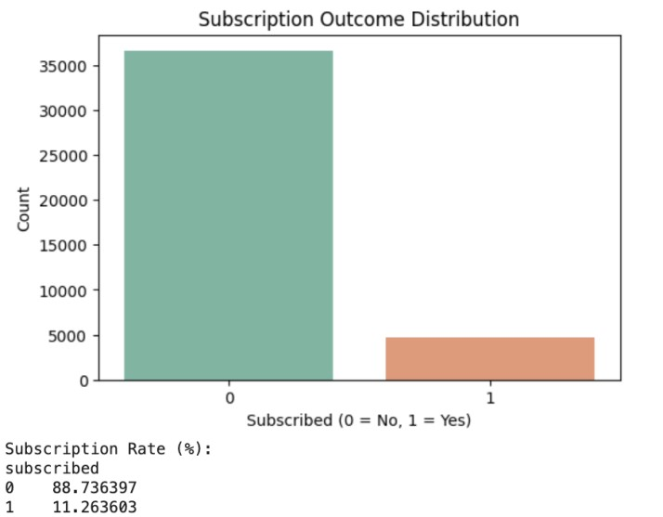

Figure
2
:

Subscription Outcome Distribution

From the Figure 2, it is clear that the dataset is highly imbalanced, with approximately 88.7% of clients not subscribing and only 11.3% subscribing to the new plan. This imbalance is a critical issue, as it suggests that the marketing campaign had a relatively low success rate. Additionally, this imbalance needs to be considered during any further analysis or modeling, as it can bias predictions towards the majority class (non-subscribers).

Univariate Analysis
The univariate analysis examined the distribution of both numeric and categorical variables to provide an initial understanding of the dataset.
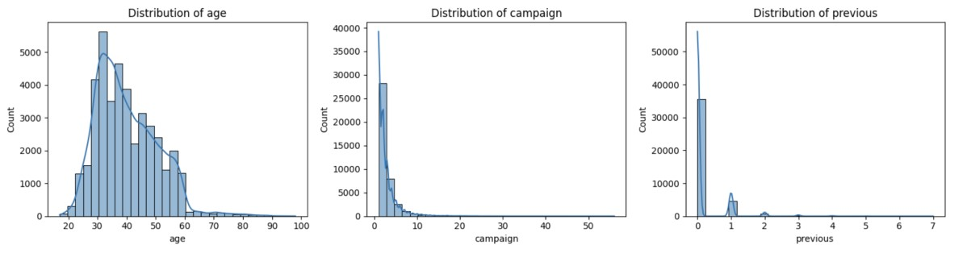

Figure 3 : Distribution of numeric variables(age, campaign, and previous)
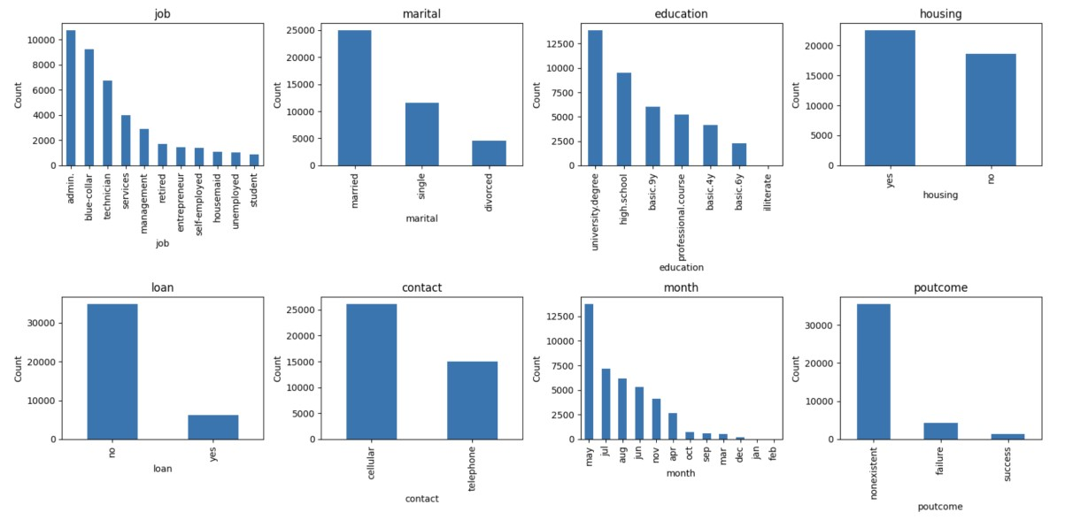

Figure 4: Distribution of categorical variables (job, marital status, education, housing loan, personal loan, contact type, month of contact, and previous campaign outcome)
The univariate exploration of numeric variables (Figure 3) confirmed skewed distributions. Age was concentrated between 25 and 45 years, peaking in the early 30s. Campaign and previous were heavily skewed, with the majority clustered at lower values.
For categorical variables (Figure 4), administrative, blue-collar, and technician roles dominated the job variable. Most customers were married and had university or high school education. More than half reported a housing loan, though personal loans were uncommon. Cellular phones were the main contact method. Campaigns were most active in May, July, and August. Previous outcomes were dominated by “nonexistent” values.
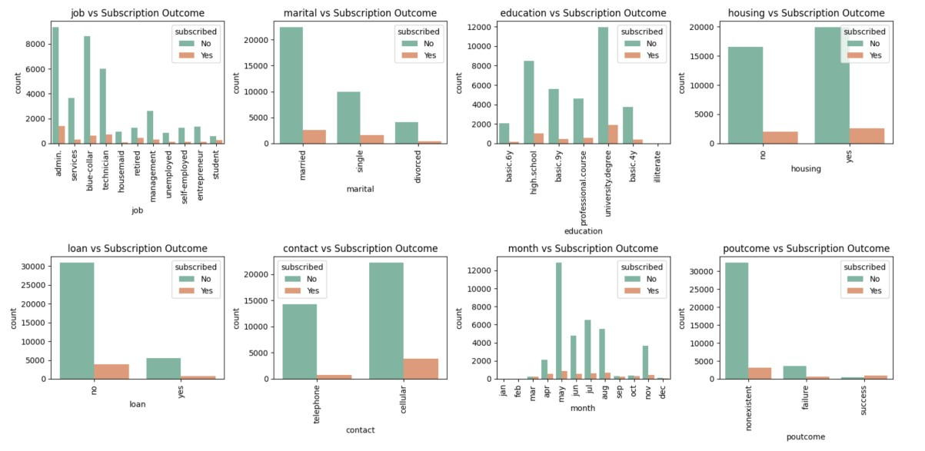
Bivariate Analysis

Figure 5 : Categorical Variables and Subscription Outcome
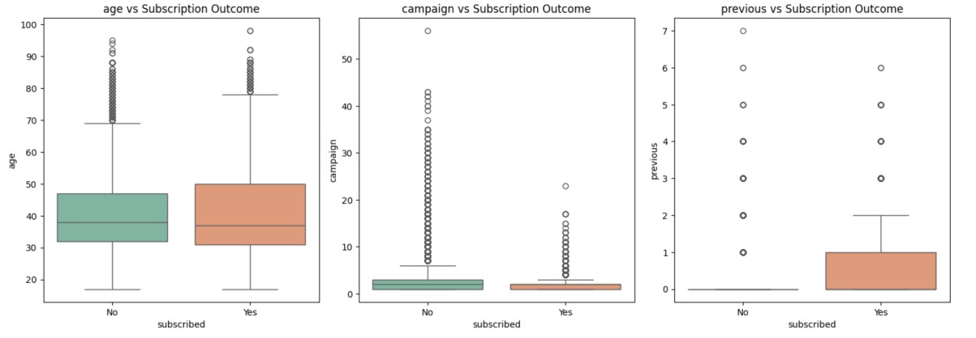

Figure
6
:

Numeric Variables and Subscription Outcome

Examining the relationship between variables and subscription (Figures 5 and 6) revealed important differences. Among categorical variables, students and retired individuals showed the highest responsiveness, while blue-collar and administrative customers subscribed less often. Single individuals subscribed more frequently than married or divorced customers. Education was positively associated with subscription, with higher rates among university graduates and professionals. Customers without loans were more likely to subscribe. Campaign method and timing were key: cellular contacts achieved better outcomes than landlines, and subscriptions peaked in May, August, and October. Customers with a previously successful outcome were substantially more likely to subscribe again.
For numeric variables, subscribers typically converted after fewer campaign contacts, while nonsubscribers were contacted repeatedly without success. Age differences were minor, though subscribers had a slightly higher median. Prior contacts were modestly higher for subscribers.

Multivariate Relationships
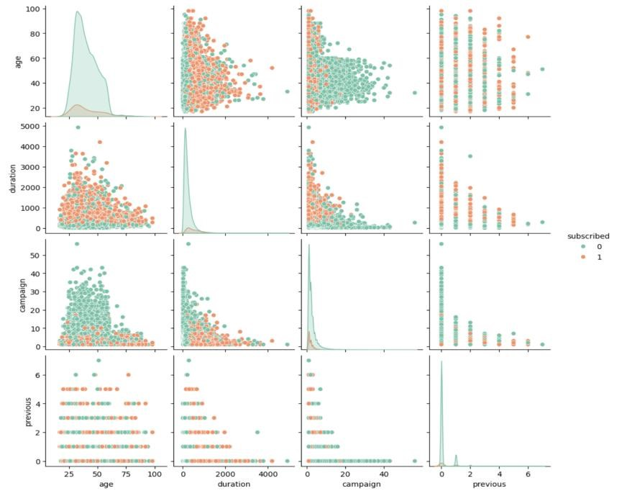

Figure 7: Pair plot of numeric variables (age, duration, campaign, previous) against subscription outcome.
The pair plot (Figure 7) reinforced earlier findings: longer duration clearly distinguished subscribers from non-subscribers, while age, campaign, and previous showed weaker separation.

Correlation Analysis
The correlation analysis was conducted to examine the relationships between numeric variables and the target variable, as well as to assess the strength of association between categorical attributes and subscription outcomes.
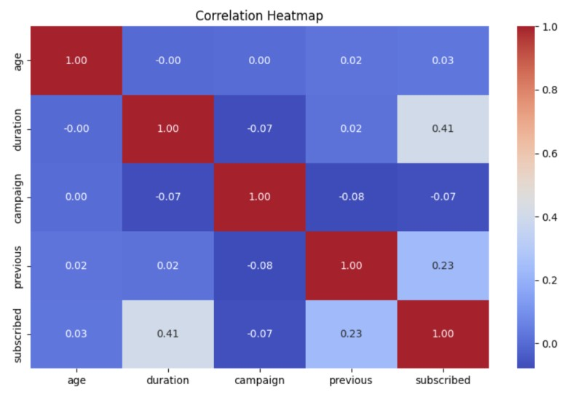

Figure 8: The univariate analysis examined the distribution of both numeric and categorical variables to provide an initial understanding of the dataset.
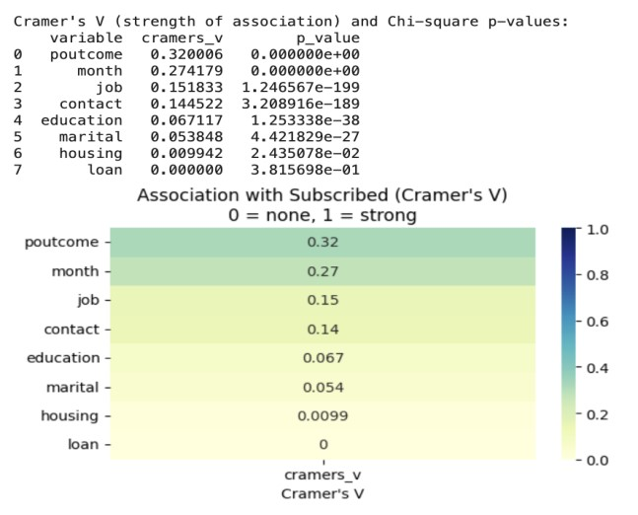

Figure 9: The univariate analysis examined the distribution of both numeric and categorical variables.
The heatmap (Figure 8) showed that duration had the strongest numeric correlation with subscription (0.41), followed by previous contacts (0.23). Age and campaign were negligible.
Cramer’s V analysis (Figure 9) confirmed that poutcome (0.32) and month of contact (0.27) were the strongest categorical predictors. Moderate associations were observed for job, contact, and education, while loan and housing had negligible impact.

Campaign Contacts and Subscription Rate
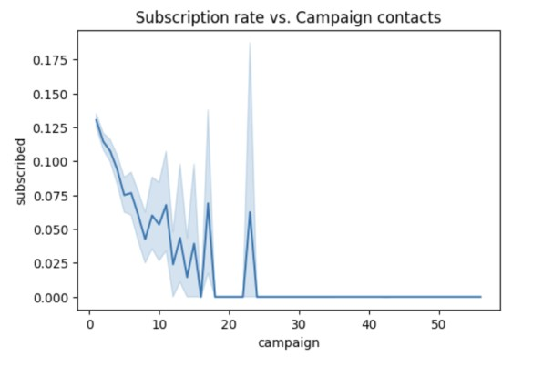

Figure 10: Relationship between the number of campaign contacts and subscription rate.
As shown in Figure 10, subscription rates peaked (12–13%) within the first few contact attempts but dropped sharply with additional calls, approaching zero beyond 10 contacts. This demonstrated that repeated contact was ineffective and potentially counterproductive.
Key Findings and Insights
The analysis produced several important findings that directly address the project’s objective of identifying customer segments most responsive to the campaign and the factors driving subscription outcomes.
Firstly, demographic characteristics showed some influence. Students and retirees were the most responsive groups, while blue-collar and administrative workers subscribed less frequently. Single customers had higher subscription rates compared to married or divorced individuals, and higher educational attainment (university degree or professional qualification) was positively associated with subscription.
Secondly, financial characteristics played a role. Customers without housing or personal loans were more likely to subscribe, indicating that lower financial obligations improved receptiveness to new plans.
Thirdly, campaign strategy emerged as a decisive factor. Campaigns conducted via cellular phones were significantly more successful than those using landlines. Timing also mattered, with conversions concentrated in May, August, and October. In addition, efficiency of contact attempts was critical: most conversions occurred within the first few calls, while repeated contacts beyond 10 attempts showed diminishing returns.
Previous engagement also influenced outcomes. Customers with a previously successful campaign outcome were far more likely to subscribe again, while those with failed or nonexistent prior outcomes were less likely to convert.
Finally, numeric drivers highlighted the importance of engagement quality. Call duration was the single strongest predictor of subscription, with longer calls strongly linked to success. Previous contacts had a moderate positive impact, whereas age and campaign frequency showed limited predictive power.
Overall, the findings confirm that campaign success depends less on broad demographics and more on execution quality, timing, and customer history. Effective, well-targeted, and timely engagement strategies were the key drivers of subscription outcomes.

Conclusion
This report set out to analyse a telecommunication marketing campaign with the goal of identifying the factors that drive customer subscription and the segments most responsive to promotional efforts. Through systematic data pre-processing and exploratory data analysis, the study established a clear understanding of both the dataset and the campaign’s performance.
The analysis revealed that while demographic factors such as occupation, education, and marital status influenced outcomes, campaign strategy was far more decisive. While students, retirees, single customers, and highly educated individuals without loans showed higher responsiveness, the strongest predictors were longer call duration, fewer contact attempts, prior successful outcomes, mobile-based outreach, and timing in May, August, and October.
The results confirm that responsiveness is not defined by who the customer is, but by how and when they are contacted. Efficient, well-timed, and high-quality engagements are the key to improving subscription rates, directly answering the project’s objective of identifying the drivers of successful campaigns.

References
- Moro, S., Cortez, P., & Rita, P. (2014). A data-driven approach to predict the success of bank telemarketing. Decision Support Systems, 62, 22-31.
- Peter, M., Mofi, H., Likoko, S., Sabas, J., Mbura, R., & Mduma, N. (2025). Predicting customer subscription in bank telemarketing campaigns using ensemble learning models. Machine Learning with Applications, 19, 100618.

- Saeed, S. E., Hammad, M., & Alqaddoumi, A. (2022, March). Predicting customer’s subscription response to bank telemarketing campaign based on machine learning algorithms. In 2022 International Conference on Decision Aid Sciences and Applications (DASA) (pp. 1474-1478). IEEE.

- Sikri, A., Jameel, R., Idrees, S. M., & Kaur, H. (2024). Enhancing customer retention in telecom industry with machine learning driven churn prediction. Scientific Reports, 14(1), 13097.

- Panwar, S., Kapur, P. K., & Singh, O. (2021). Predicting diffusion dynamics and launch time strategy for mobile telecommunication services: an empirical analysis. Information Technology and Management, 22(1), 33-51.

- Bayer, J. (2010). Customer segmentation in the telecommunications industry. Journal of Database marketing & customer strategy management, 17(3), 247-256.

